Task 5: AEM

**AEM TASK – 5**

### **Newsroom Implementation and Custom Features**

#### **Creating News Article Pages:**

* Create five unique news article pages under /content/us/en/news.
* Each page should use the News Component to display the title, news details, and published date.

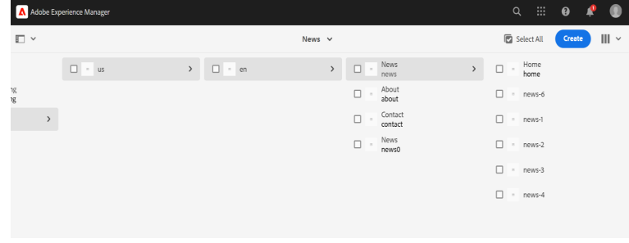

#### **Header Experience Fragment:**

* Implement a Header as an Experience Fragment to maintain consistency across pages.

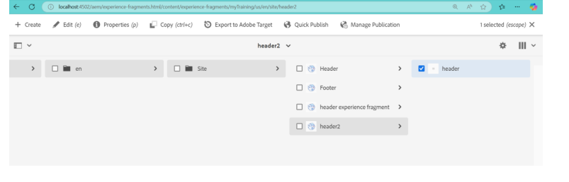

#### **Home Page linking 5 other news pages:**

* A News section should be included on the Home Page, linking to the five news pages.

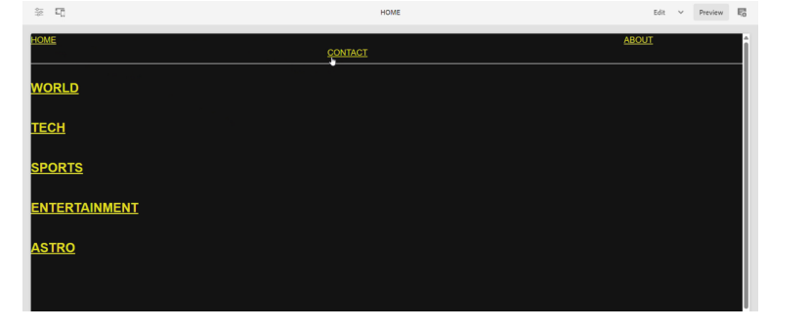

#### **Contact Us Page with Social Media Links:**

* Develop a Contact Us page with contact details such as mobile number, office address, and email.
* Include social media links for better engagement.

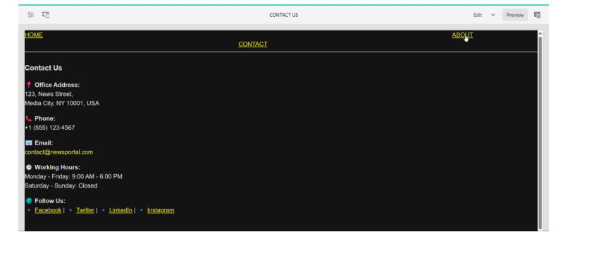

#### **About Us Page using Teaser, Image, Text, and Title Components:**

* Design an About Us page featuring information about the journalist using Teaser, Image, Text, and Title Components.

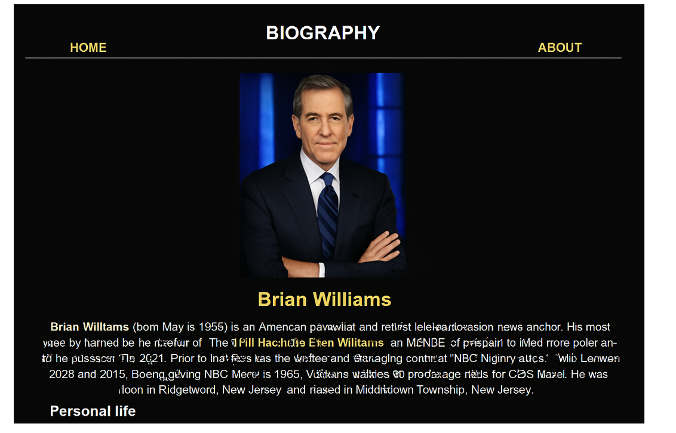

#### **Creating Footer Experience Fragment:**

* Build a Footer in Experience Fragments.
* The footer should include a Social Media Section displaying social media links via the Teaser Component.

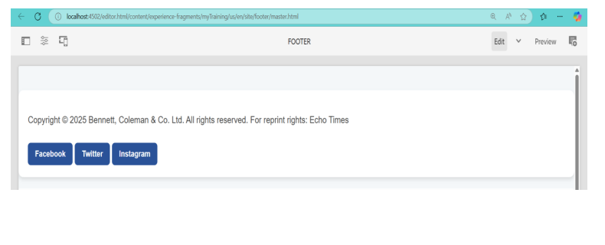

#### **Creating a Custom Service:**

* Develop a custom service that prints "Hello World".
* Call this service from the News Component Sling Model.
* Log the message in AEM logs for reference.

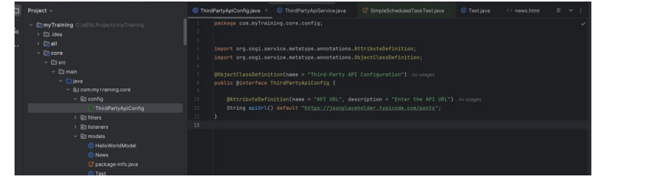

#### **Creating Custom Configurations for Third-Party API:**

* Create a custom configuration for a third-party API (e.g., https://jsonplaceholder.typicode.com/posts).
* Fetch and display API data in JSON format.
* Log the API data for tracking and debugging.

This setup ensures a well-structured newsroom with a dynamic and flexible content management approach in AEM.